|  |  |
| --- | --- |
|  | **HTML5 Test**  **Semester 2, 2021**  **ISCG6420 IWD**  **Task 1** |
| School of Computing Electrical and Applied Technology | **Date:** Tuesday, 14 Sep, 2021  **Commencement Time:** 8:45 AM  **Time Allowed:** 40 min  **Marks:** 34 |
|  |  |

**Please fill in your name and your student ID.**

|  |  |
| --- | --- |
| Name: | student ID: |

**Instructions:**

|  |  |
| --- | --- |
| 1. | This is semi-open book test. IWD demo website is closed. |
| 2. | There are 3 tasks in this test. Each task is 40 min, you need to upload each task after 40 min. Submission will be allowed for 10 min only. You should complete all the tasks. You should attempt all the requirements. |
| 3 | Please keep each test part in corresponded folder, for example Part_1. Please save all files during the test frequently. In the end of each 40 minutes, re-name your folder with your name (example: Part_1_Mary_popins), Zip this folder and submit. |

**Task 1 Canvas 34 MARKS**

**Instructions**

1. Create an HTML file named dog.html. Based on using HTML5, define a canvas element with the following properties:

Width: 900px

Height: 700px

Border: red, solid, 5px.

Background: #D9B3FD

(3 marks)

2. Write JavaScript functionality to draw one circle and set the

Colour ,

Radius,

Border,

property

The circle represents an ant’s head.

(4 marks)

3. Write JavaScript functionality to draw another circle with following properties:

Size,

Fill colour,

The square should be representing the ant’s body.

(3 marks)

4. Write JavaScript functionality to draw a yellow circle (sun)

(4 marks)

5. Write JavaScript functionality to draw 2 semi-circlet hat represents antennas.

(4 marks)

6. The canvas should look like this:

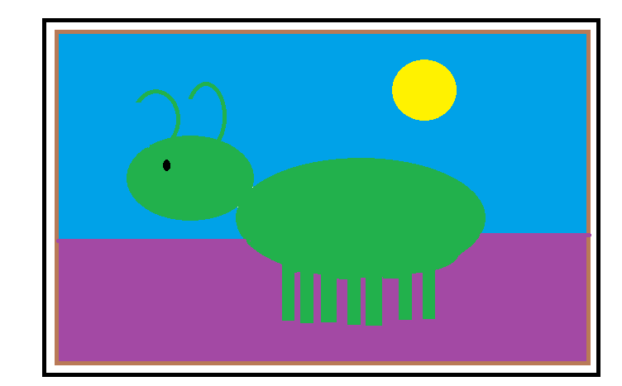

10. Write JavaScript functionality to move the sun diagonally. Set interval (timer) for every 180 milliseconds for its movement. Remember to clear the area of previously drawn sun circle.

(12 marks)